**ModelSim test vectors**

Test vector for encryption and decryption of 256 bits

Input (256):

**256'h_dbf201c6d42d01c6_130a01c6d42601c6_532201c6d43101c6_455c01c6d54c01c6**

Output (256):

**256'h_8e9f01c6d54d01c6_4ddc01c6d57e01c6_a15801c6d7bd01c6_bc9d01c6d6f801c6**

**Mixcolumn256**

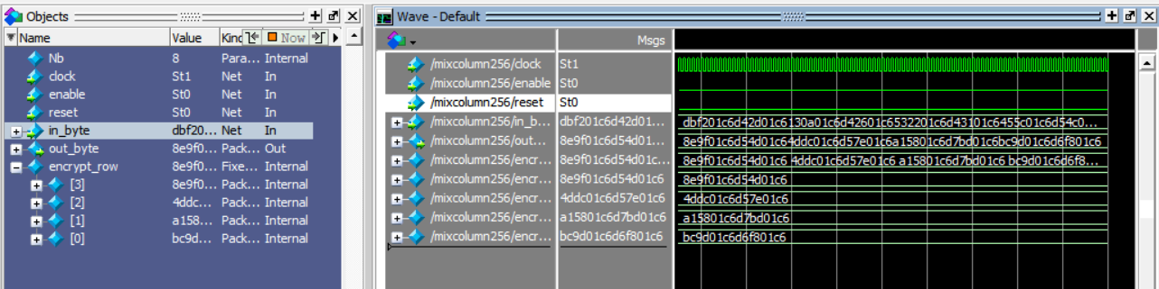**For encrypt**

**Inver_mixcolumn256**

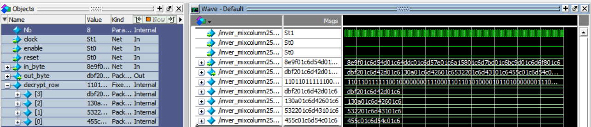**For decrypt**

Test vector for encryption and decryption of 128 bits

input (128):

**128'h_dbf201c6_130a01c6_532201c6_455c01c6**

output (128):

**128'h_8e9f01c6_4ddc01c6_a15801c6_bc9d01c6**

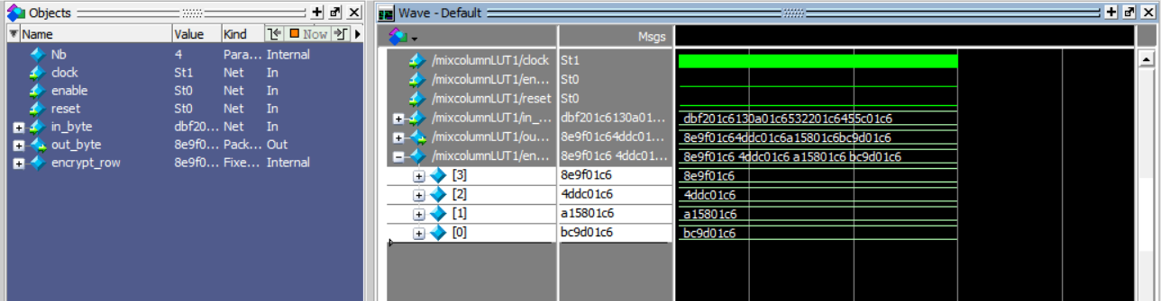**For encrypt:**

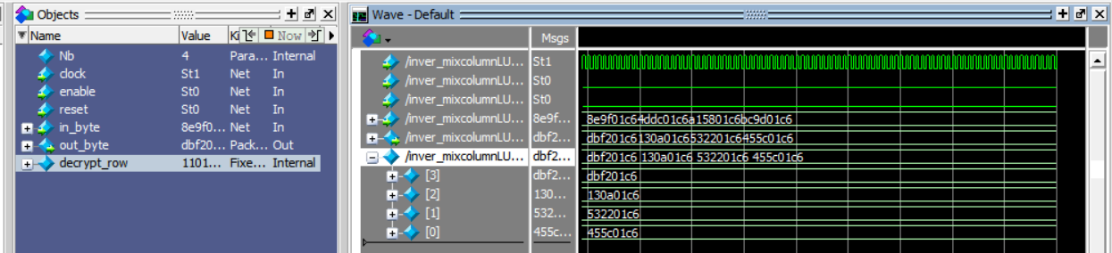**For decrypt:**